Project Planning Phase
Project Planning Template (Product Backlog, Sprint Planning, Stories, Story points)

Date | 28 October 2026
Team ID | Individual Project - Ujjawal Rathod
Project Name | Electric Vehicle Market Performance & Insights
Maximum Marks | 8 Marks

Product Backlog, Sprint Schedule, and Estimation (4 Marks)
Use the below template to create product backlog and sprint schedule
Sprint | Functional Requirement (Epic) | User Story Number | User Story / Task | Story Points | Priority | Team Members
Sprint-1 | Data Preparation | USN-1 | As an analyst, I can combine the training and test CSV files into one unified EV dataset for analysis. | 8 | High | Ujjawal Rathod
Sprint-1 | Data Quality | USN-2 | As an analyst, I can validate the 300,000-row dataset, standardize field types, and check missing or duplicate records. | 5 | High | Ujjawal Rathod
Sprint-1 | Calculated Measures | USN-3 | As a dashboard developer, I can define consistent sales, driving-range, efficiency, and rating measures. | 5 | High | Ujjawal Rathod
Sprint-1 | Data Documentation | USN-4 | As a project reviewer, I can see the dataset sources, scope, fields, and key assumptions documented. | 2 | Medium | Ujjawal Rathod
Sprint-2 | Sales Analysis | USN-5 | As a market strategy user, I can compare EV sales across vehicle categories to identify high-volume segments. | 5 | High | Ujjawal Rathod
Sprint-2 | Trend Analysis | USN-6 | As a market strategy user, I can examine model-year trends from 2018 to 2026 to support planning decisions. | 5 | High | Ujjawal Rathod
Sprint-2 | Competition Analysis | USN-7 | As a BI manager, I can rank manufacturers and view market share using a FIXED LOD denominator. | 8 | High | Ujjawal Rathod
Sprint-2 | Dashboard Filters | USN-8 | As a dashboard user, I can filter views by region, vehicle category, and model year without misleading the market-share calculation. | 2 | Medium | Ujjawal Rathod
Sprint-3 | Battery Technology | USN-9 | As a researcher, I can compare the market share and adoption of NMC, LFP, NCA, Sodium-Ion, and Solid-State batteries. | 5 | High | Ujjawal Rathod
Sprint-3 | Range Analysis | USN-10 | As a researcher, I can compare driving range by vehicle category and battery chemistry. | 8 | High | Ujjawal Rathod
Sprint-3 | Geographic Analysis | USN-11 | As a BI manager, I can explore manufacturing-country and market-region patterns in the dashboard. | 5 | Medium | Ujjawal Rathod
Sprint-3 | Customer Satisfaction | USN-12 | As a researcher, I can compare average customer ratings across vehicle categories. | 2 | Medium | Ujjawal Rathod
Sprint-4 | Executive Storytelling | USN-13 | As a stakeholder, I can explore an overview and three persona-focused Tableau Story views for distinct business questions. | 8 | High | Ujjawal Rathod
Sprint-4 | Tableau Publishing | USN-14 | As a reviewer, I can open the published Tableau dashboard and Story with the intended interactive filters. | 5 | High | Ujjawal Rathod
Sprint-4 | Web Integration | USN-15 | As a visitor, I can access the Tableau content through the Flask web portal deployed on Vercel. | 5 | High | Ujjawal Rathod
Sprint-4 | Release Readiness | USN-16 | As a reviewer, I can find project documentation and source files in the repository and verify the deployed portal. | 2 | Medium | Ujjawal Rathod

Project Tracker, Velocity & Burndown Chart: (4 Marks)
Sprint | Total Story Points | Duration | Sprint Start Date | Sprint End Date (Planned) | Story Points Completed (as on Planned End Date) | Sprint Release Date (Actual)
Sprint-1 | 20 | 6 Days | 29 Oct 2026 | 03 Nov 2026 | Pending | Pending
Sprint-2 | 20 | 6 Days | 05 Nov 2026 | 10 Nov 2026 | Pending | Pending
Sprint-3 | 20 | 6 Days | 12 Nov 2026 | 17 Nov 2026 | Pending | Pending
Sprint-4 | 20 | 6 Days | 19 Nov 2026 | 24 Nov 2026 | Pending | Pending
Planning note: Sprint dates are proposed. Update “Pending” completion and release fields from actual sprint records.
Velocity:
Example: if a team completes 20 story points in a 10-day sprint, average velocity per day is calculated as follows.
Average velocity = completed story points / sprint duration = 20 / 10 = 2 story points per day
Burndown Chart:
A burndown chart shows remaining work against time. The chart below is an illustrative 20-point sprint example; its sample actual line is not recorded project data and should be replaced with daily sprint tracking.
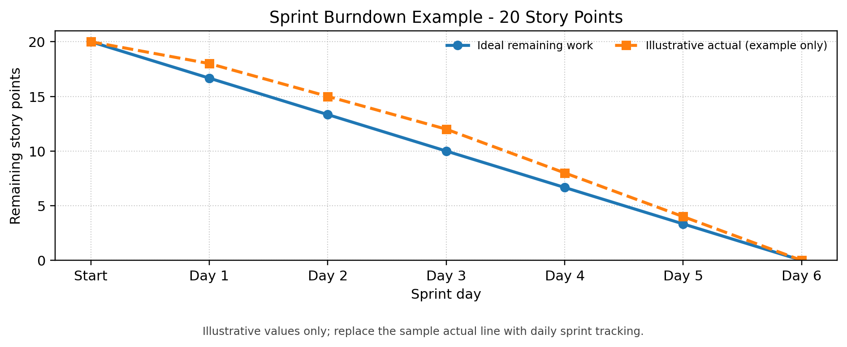
https://www.visual-paradigm.com/scrum/scrum-burndown-chart/
https://www.atlassian.com/agile/tutorials/burndown-charts

Reference:
https://www.atlassian.com/agile/project-management
https://www.atlassian.com/agile/tutorials/how-to-do-scrum-with-jira-software
https://www.atlassian.com/agile/tutorials/epics
https://www.atlassian.com/agile/tutorials/sprints
https://www.atlassian.com/agile/project-management/estimation
https://www.atlassian.com/agile/tutorials/burndown-charts

